
CHURCHLANDS SENIOR HIGH SCHOOL
MATHEMATICS SPECIALIST 3, 4 Last Test 2016
NON-Calculator Section
Chapters 9 to 12

Name________________________________ Time: 20 minutes
Total: 22 marks

- [14 marks]
(a) Determine the indefinite integrals.

(i) dx [2 marks]

(ii) dx [4 marks]

(b) Use the substitution u = + 3 to find dx. [4 marks]

(c) dx [2]

2 [7 marks]

Show that the volume of the solid obtained by rotating the region bounded by , , and around the axis is [4 marks]

3 [3 marks]
Find the general solution to the differential equation


CHURCHLANDS SENIOR HIGH SCHOOL
MATHEMATICS SPECIALIST 3, 4 Last Test 2016
Calculator Assumed Section
Chapters 9 to 12

Name________________________________ Time: 35 minutes
Total: 30 marks
4. [11 marks]

(a) The equation of motion of a body is given by + 16x = 0, where x is the distance of the body (in cm) to a fixed point O and t is time in seconds. It is known that the body starts moving from O with a velocity of −1 cm s⁻¹.Show clearly that x = Asin (ωt + α) giving the values of A, ω (where ω > 0) and α. [6]

(b) The equation of motion of another body is given by x = 2 cos (0.5 t ).the average speed of the body in the first ten seconds. .Show clearly how you obtained your answer. [5]

5 [4 marks]
Refer to the differential equation . Determine the specific solution of the differential equation that passes through (1, 1). Graph the slope field below and graph the solution too.

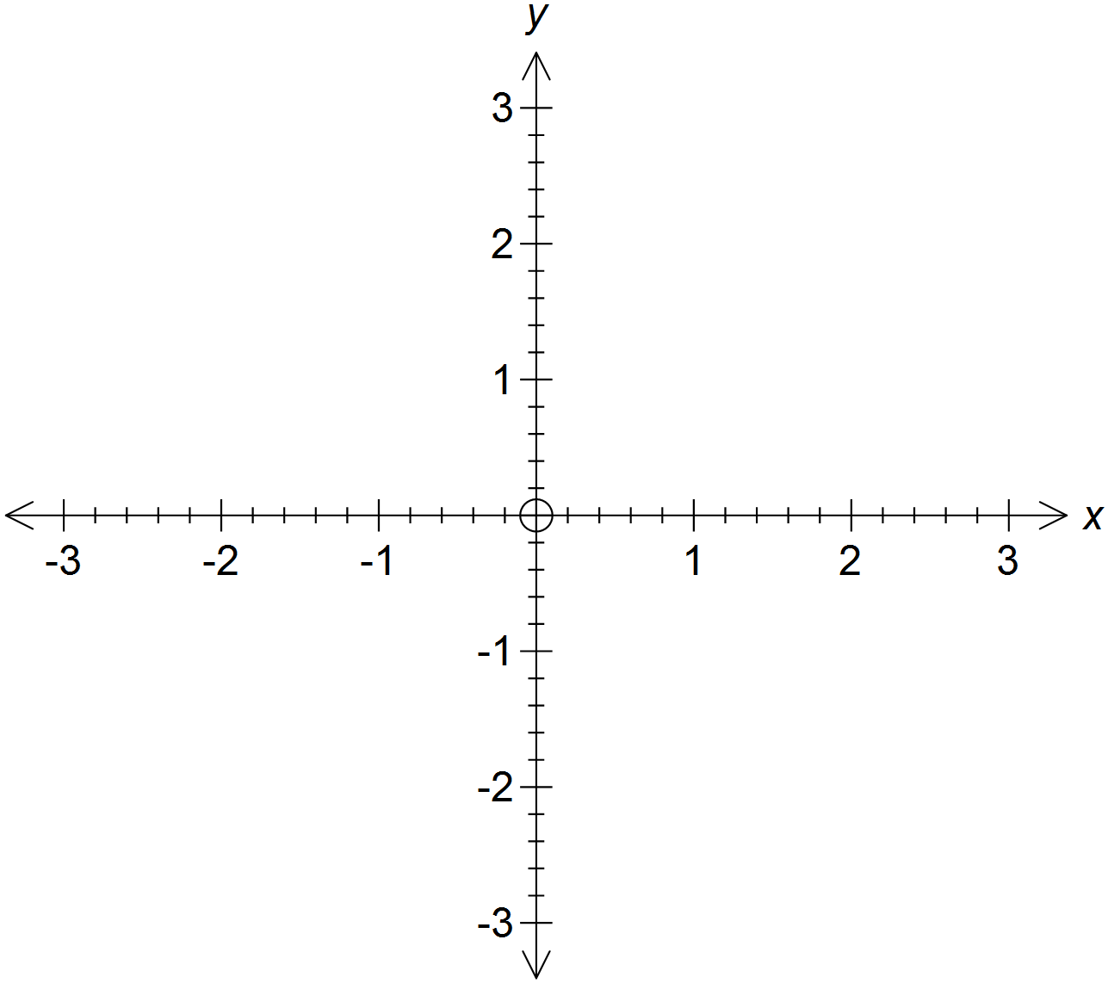

6. [7 marks]
A randomly selected group of 20 Year 12 girls have a mean height of 160 cm with a standard deviation of 1.5 cm.
(a) Use the data to predict the height and standard deviation of all WA Year 12 girls.
(3)

(b) State the 95% confidence limits for the mean height of Year 12 girls in WA. (2)

(c) Explain the difference between 95% confidence limits and 90% confidence limits.
(2)

7. [8 marks]

The number of deaths from Avian (bird) Influenza in Cambodia was reported to the
World Health Organisation (WHO).
Over the years 2010-2015 the number of deaths from Avian Influenza can be
determined by the equation where is in years where

(a) Determine the number of deaths in Cambodia from Avian Influenza in 2012. (2)

(b) (i) Find the rate of increase of cases of Avian Influenza in 2015. (3)

(ii) Is the number of cases increasing or decreasing in 2013? (1)

(c) Sketch the shape of the curve (2)

